A)

select customers.customerName, orders.orderNumber, sum(orderdetails.quantityOrdered) as total_quantity from customers inner join orders on customers.customerNumber = orders.customerNumber inner join orderdetails on orders.orderNumber = orderdetails.orderNumber group by orderdetails.orderNumber;

B)

select customers.customerName from customers left join orders on customers.customerNumber = orders.customerNumber where orders.customerNumber is null;

C)

select concat(employees.firstName,' ', employees.lastName) as Employee_Name, count(customers.customerNumber) as NumberOfCustomers from employees left join customers on employees.employeeNumber = customers.salesRepEmployeeNumber group by employees.salesRepEmployeeNumber order by count(customers.customerNumber) desc;

D)

For All the Products(with repetition according to their quantity)

select products.productName as Product from customers inner join orders on orders.customerNumber = customers.customerNumber inner join orderdetails on orders.orderNumber = orderdetails.orderNumber inner join products on products.productCode = orderdetails.productCode where customers.customerName = "Muscle Machine Inc”;

Without repetition

select distinct(products.productName) as Products from customers inner join orders on orders.customerNumber = customers.customerNumber inner join orderdetails on orders.orderNumber = orderdetails.orderNumber inner join products on products.productCode = orderdetails.productCode where customers.customerName = "Muscle Machine Inc";

E)

select products.productName as Product, count(orderdetails.quantityOrdered) from products inner join orderdetails on products.productCode = orderdetails.productCode group by orderdetails.productCode;

F)

select products.productName from products left outer join orderdetails on products.productCode = orderdetails.productCode where orderdetails.productCode is null;

__________________________________________________________________________________________________________________________________________________________________________

Q-2

A.

select avg(mark) from student_mark;

B.

select student6.name as Name, max(student_mark.mark) as Maximum_Marks from student6 left join student_mark on student6.id = student_mark.student_id group by student_mark.student_id;

C.

select month(exam_dt) as Month, max(mark) as Maximum_Marks from student_mark group by month(exam_dt);

D.

select month(exam_dt) as Month, avg(mark) as Average from student_mark group by month(exam_dt);

__________________________________________________________________________________________________________________________________________________________________________

Q2–

MariaDB [(none)]> CREATE DATABASE Assignment_4;

Query OK, 1 row affected (0.00 sec)

MariaDB [(none)]> USE Assignment_4;

Database changed

MariaDB [Assignment_4]> CREATE TABLE Number(rnumber float NULL DEFAULT NULL);

Query OK, 0 rows affected (0.07 sec)

MariaDB [Assignment_4]> DELIMITER $$

MariaDB [Assignment_4]> CREATE PROCEDURE random_gen(IN n INT)

-> BEGIN

-> DECLARE i INT DEFAULT 1;

-> WHILE i <= n DO

-> INSERT INTO Number (rnumber) value (RAND());

-> SET i = i + 1;

-> END WHILE;

-> SELECT * FROM Number;

-> END$$

Query OK, 0 rows affected (0.03 sec)

MariaDB [Assignment_4]> DELIMITER ;

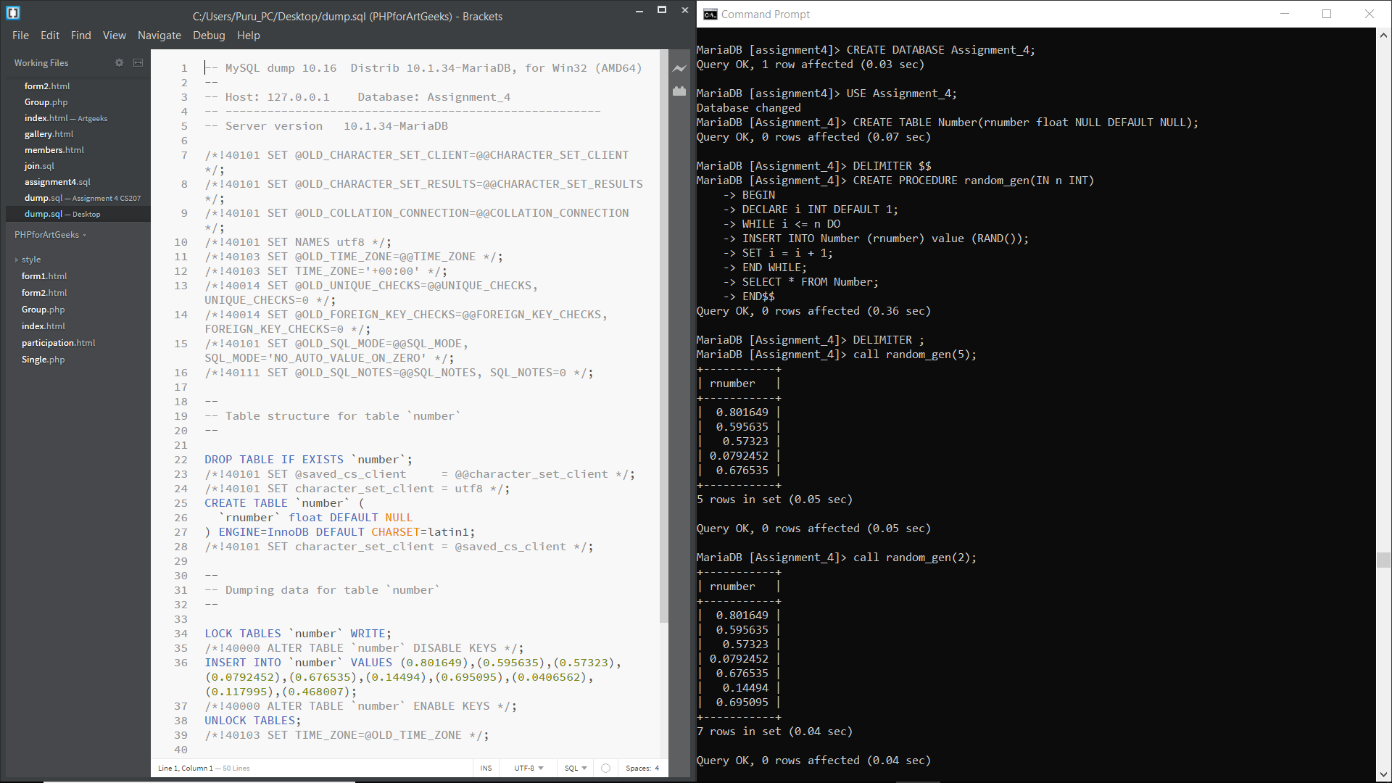

__________________________________________________________________________________________________________________________________________________________________________

Q2.

MariaDB [Assignment_4]> delimiter $$

MariaDB [Assignment_4]> CREATE PROCEDURE Sum_Even(IN x INT)

-> BEGIN

-> DECLARE A INT DEFAULT 0;

-> DECLARE i INT DEFAULT 1;

-> WHILE i <= x DO

-> IF (i % 2 = 0) THEN

-> SET A = A + i;

-> END IF;

-> SET i = i + 1;

-> END WHILE;

-> SELECT A;

-> END$$

Query OK, 0 rows affected (0.03 sec)

MariaDB [Assignment_4]> delimiter ;



